Postprocessor user’s guide for Mitsubishi VR33 with right angel head

NOTE: This user’s guide is for the postprocessor which created at Sep, 18th, 2006.

This is a 4-Axis Milling Machine with Rotary Head. It built for Mitsubishi VR33 with Right angle head.

In order to use this postprocessor correctly, you should follow the instruction below.

In the machine tool view:
1. Create Carrier
Choose the Create Tool icon.
Set the Type option to mill_contour.
Choose the CARRIER icon.
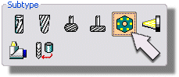
Set the Parent Group option to NULL_MACHINE.
Set the Name to Carrier
OK to begin creating the tool carrier.
2. Create Vertical Head
Choose the Create Tool icon.
Set the Type option to mill_contour.
Choose the HEAD icon.
Set the Parent Group option to Carrier.
Set the Name to Head_Vertical
OK
Specify the spindle axis
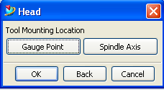
For vertical spindle, the vector should be (0, 0, 1)
3. Put all the tools used in vertical spindle under the vertical head.
4. Create Horizontal Head
5. Put all the tools used in horizontal spindle under the horizontal head.

Then you can use this postprocessor to output the G code in the program order view directly.

